Chapter 18, Problem 9.

Determine the Fourier transforms of the signals in Fig. 18.34.

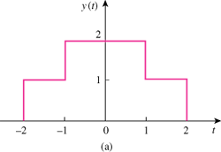

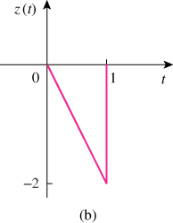

Figure 18.34
For Prob. 18.9.

